
App 1: The Polyglots in the Playroom
Playmat
Learning intentions: We are learning to express what we like and what we don’t like in _______ (language).
Success criteria: I can say ‘I like _____’ or ‘I don’t like _____’ in _______ (language).
Resources: App 1, App 1 guide, App 1 like/don’t like printable.pdf
English; Visual Arts
Students create a self-portrait with images of what they like/don’t like (e.g. food, colours, animals) and trace or copy the phrase ‘I like _____’ or ‘I don’t like _____’ in the target language.
Australian Curriculum links (Foundation): ACELA1429 and ACAVAM108

Science
Using the Playmat activity as a launch for introducing data collection and graphing, conduct a whole-class survey to determine students’ likes/dislikes about a particular topic; for example, ‘What is your favourite animal/food/sport?’
Australian Curriculum links (Foundation): ACSIS014
Digital Technologies
As a continuation of the science activity, students can use ICT capabilities (perhaps working with their buddy students) to create a digital representation of survey results.
Australian Curriculum links (Foundation): ACTDIP003

English
Encourage small groups of students to introduce themselves and to talk about their own likes/dislikes, using a few sample items from the Playmat activity. (These are available from the printable, e.g. pictures of food or a soccer ball.) Students can practise saying what they like/don’t like in the target language.
Australian Curriculum links (Foundation): ACELY1784 and ACELA1429
Assessment opportunities: The apps have been developed with subject matter experts. They are aligned to and support the learning outcomes of the Australian Curriculum: Languages for F–2.
You can find specific links to the Australian Curriculum for your language on the ELLA website, in the Educator Zone App Toolkit.
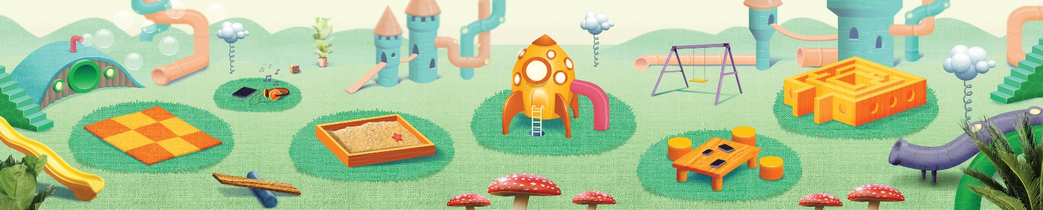


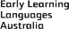
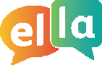
ELLA is funded by the Australian Government Department of Education, Skills and Employment and is managed by Education Services Australia. © 2021 Commonwealth of Australia, unless otherwise indicated. This material, other than Commonwealth trade marks in The Polyglots characters and The Polyglots logo, may be used in accordance with the Creative Commons BY-NC 4.0 licence unless otherwise indicated.

