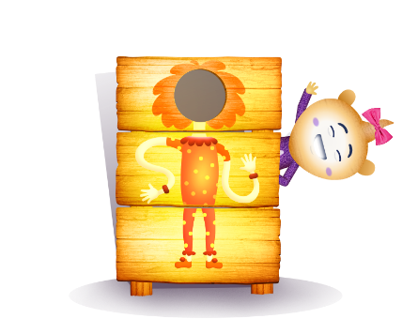
App 5: The Polyglots at the Circus
Flip a part
English
What is an adjective? This experience explores the use of adjectives to describe body parts. Explore how the inclusion of an adjective in a sentence can enhance the meaning. Encourage students to form their own sentences in English to describe themselves. For example, ‘I have long hair’, ‘I have brown eyes’. Then practise some of the sentences encountered within the app, using the target language. Refer to the App 5 guide.
Australian Curriculum links (Foundation): ACELA1434
Learning intentions: We are learning how to label and describe parts of the body in ________ (language).
Success criteria: I can name parts of the body in ________ (language).
Resources: App 5, App 5 guide, A3 paper, ‘Parts of the body poster’ printable, ‘Flip-a-part cards’ printable, App 5 song MP3 file, a variety of dress-ups and cultural costumes
English
Print enough copies of the Flip-a-part cards for students to play in pairs or in small groups. Encourage students to practise using the target language when playing and matching the cards.
Australian Curriculum links (Foundation): ACELY1646
Visual Arts
Students design and create funny characters with different body parts. Provide students with an A3 piece of poster paper and encourage them to draw their characters. Using the ‘Parts of the body’ poster as a guide, students could write, copy or trace the name of some body parts to label their drawing using the target language.
Australian Curriculum links (Foundation): ACAVAM108
Drama
This experience shows a Polyglots character dressed in traditional clothing from a country where the target language is spoken. Provide students with a variety of dress-ups and cultural clothing and encourage them to create their own role-play scenarios using the target language. To explore other cultural clothing you could print the ‘Parts of the body’ printable for some or all of the 13 languages available on it.
Australian Curriculum links (Foundation): ACADRM027
Assessment opportunities: The apps have been developed with subject matter experts. They are aligned to and support the learning outcomes of the Australian Curriculum: Languages for F–2.
You can find specific links to the Australian Curriculum for your language on the ELLA website, in the Educator Zone App Toolkit.
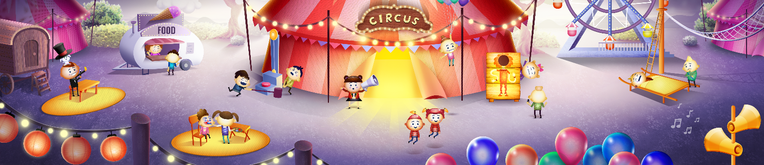

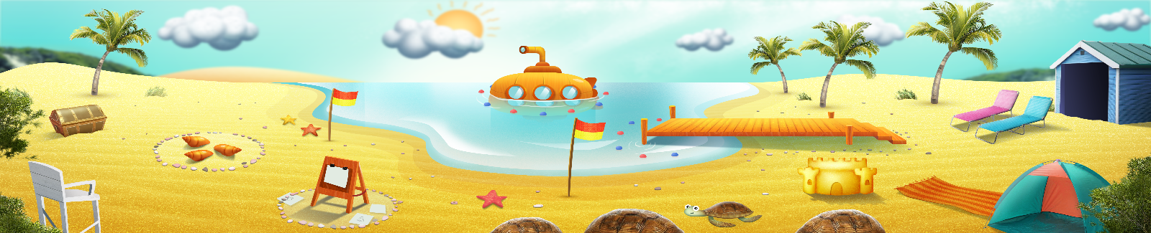


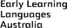

ELLA is funded by the Australian Government Department of Education, Skills and Employment and is managed by Education Services Australia. © 2021 Commonwealth of Australia, unless otherwise indicated. This material, other than Commonwealth trade marks in The Polyglots characters and The Polyglots logo, may be used in accordance with the Creative Commons BY-NC 4.0 licence unless otherwise indicated.

