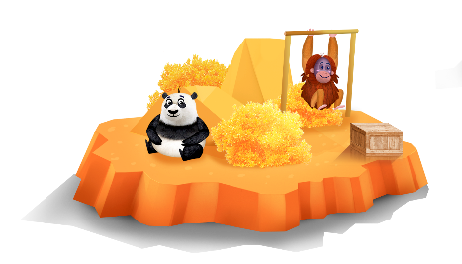
App 4: The Polyglots at the Zoo
Animal feeding time
English; Science
Conduct a whole-class discussion to identify the basic survival needs of the zoo animals in the app, including what they eat in their natural habitats. Spend time talking about the features of their natural environments, such as trees and access to water. Show students different images of these environments from books and/or the internet. What are the similarities and differences? You could also explore the habitats of animals that live within the countries where the target language is spoken.
Australian Curriculum links (Foundation): ACELY1646 and ACSSU002
Mathematics
In this learning experience, students hear the names of various types of fruit. Add a list of these to the board and encourage students to practise saying the names in the target language. Next, demonstrate how to conduct a simple survey for students to determine their classmates’ favourite fruits. The questions could be as simple as ‘Do you like apples or bananas?’ Compare results and possibly create a class graph.
Australian Curriculum links (Foundation): ACMSP011
Learning intentions: We are learning about the different types of food preferences and habitats of zoo animals.
Success criteria: I can talk about the types of food preferences and habitats of some zoo animals.
Resources: App 4, App 4 guide, ‘Hungry, thirsty, delicious’ printable, ‘Polyglots toys’ printable, A3 paper, various craft materials such as cardboard boxes, icy-pole sticks, straws (paper if possible), glue
Assessment opportunities: The apps have been developed with subject matter experts. They are aligned to and support the learning outcomes of the Australian Curriculum: Languages for F–2.
You can find specific links to the Australian Curriculum for your language on the ELLA website, in the Educator Zone App Toolkit.

English
Talk about the different responses from the animals and the phrases and language they use: ‘I’m hungry’, ‘Yum!’, ‘Yuk!’, ‘I like/I don’t like’. (Hint: the ‘Hungry, thirsty, delicious’ printable may be a useful prompt.) Then organise students into small groups and, using the Polyglots toys printable –either the images or the toys – encourage students to practise saying the phrases as they take it in turns to play with and ‘feed’ the toy animals.
Australian Curriculum links (Foundation): ACELY1646 and ACELY1784
Visual Arts; Science; Design and Technologies
Students design and create a diorama for the habitat of a selected zoo animal from App 4. They draw their ideas first (using A3 paper) and then, with some guidance, build their diorama using the available resources such as straws, cardboard boxes, icy-pole sticks.
Australian Curriculum links (Foundation):
ACAVAM107, ACSSU002, ACTDEP006 and ACTDEP007
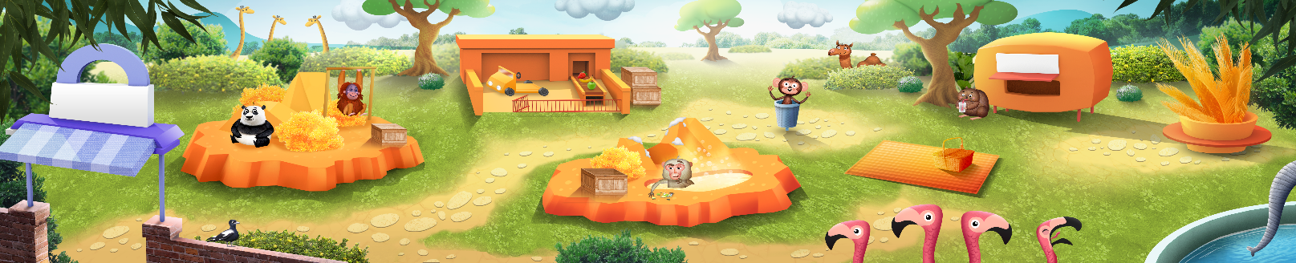

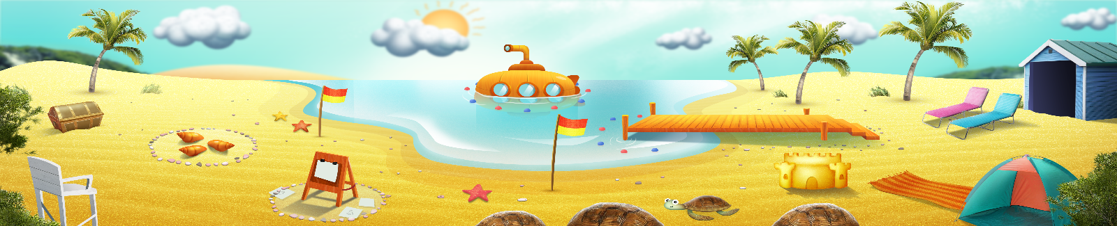


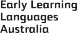

ELLA is funded by the Australian Government Department of Education, Skills and Employment and is managed by Education Services Australia. © 2021 Commonwealth of Australia, unless otherwise indicated. This material, other than Commonwealth trade marks in The Polyglots characters and The Polyglots logo, may be used in accordance with the Creative Commons BY-NC 4.0 licence unless otherwise indicated.

