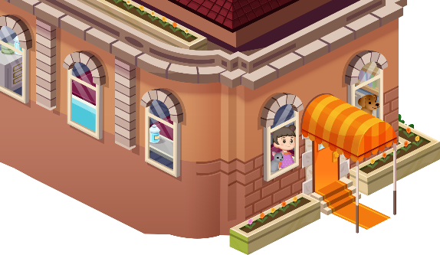
App 10: The Polyglots at the Pet Park
Pet check-in
Learning intentions: We are learning how to measure the weight and length of different items using ___________________ (language).
Success criteria: I can measure the weight and length of objects in ___________________ (language).
Resources: App 10, App 10 guide, balance scales, kitchen scales, 30cm rulers, A3 paper, toy animals
Mathematics
Students can measure the length of different classroom items using informal (for example, finger lengths) and formal (centimetres) measurements. Students can make predictions for the length, measure the actual length and record the details in a chart. Encourage students to use the target language when providing their answers.
Australian Curriculum links (Year 2): ACMMG037
English; Mathematics; Visual Arts
Students can create their own pet profile card for a pet of their choice. Using A3 paper, students can illustrate a pet and provide details of the animal type, colour, weight and length using the target language.
Australian Curriculum links (Year 2): ACELY1671, ACMMG038, ACMMG037 and ACAVAM108

English
In the ‘Pet check-in’ learning experience, the player has the opportunity to care for various pets. Generate a class discussion about the importance of caring for animals and the various responsibilities that come with owning a pet. Encourage students to talk in small groups and to report their thoughts back to the whole class.
Australian Curriculum links (Year 2): ACELY1789
Assessment opportunities: The apps have been developed with subject matter experts. They are aligned
to and support the learning outcomes of the Australian Curriculum: Languages for F–2.
You can find specific links to the Australian Curriculum for your language on the ELLA website, in the
Educator Zone App Toolkit.
Mathematics
Students can measure the weight of different toy animals using balance scales and kitchen scales. Students can make predictions of the weight of the animal, measure the weight and record the details in a chart. Encourage students to use the target language for number, centimetres and kilograms when providing their answers.
Australian Curriculum links (Year 2): ACMMG038

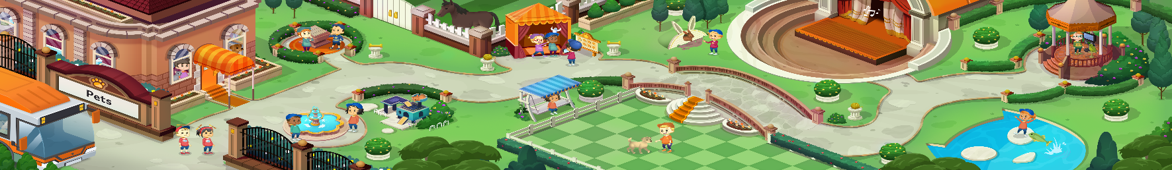


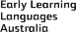

ELLA is funded by the Australian Government Department of Education, Skills and Employment and is managed by Education Services Australia. © 2021 Commonwealth of Australia, unless otherwise indicated. This material, other than Commonwealth trade marks in The Polyglots characters and The Polyglots logo, may be used in accordance with the Creative Commons BY-NC 4.0 licence unless otherwise indicated.

