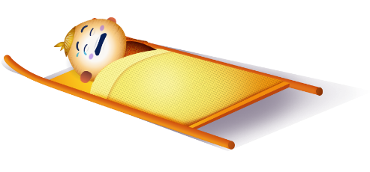
App 5: The Polyglots at the Circus
First aid helper
Drama
Give students an opportunity to re-enact the scenarios they encountered during the ‘First aid helper’ learning experience. Provide dress-ups and props and encourage students to take on the role of the characters from the app. Encourage students to practise some of the phrases they heard, such as ‘My hand hurts!’
Australian Curriculum links (Foundation): ACADRM028
Assessment opportunities: The apps have been developed with subject matter experts. They are aligned to and support the learning outcomes of the Australian Curriculum: Languages for F–2.
You can find specific links to the Australian Curriculum for your language on the ELLA website, in the Educator Zone App Toolkit.
English; Health and Physical Education
The Polyglots characters in this learning experience become injured and need help from nurses and doctors to become well again. Generate a class discussion about various people in our community who can help us. What do they do? Where do they work? When might we need these people to help us? Students may like to illustrate their understandings.
Australian Curriculum links (Foundation): ACELY1784 and ACPPS003
English; Visual Arts
Students respond to this experience by illustrating the events in sequential order. Explore the concept of ‘first’ ‘next’ and ‘last’ and encourage students to include some of the language from the app. They can write, copy, or trace some of the phrases they have learnt.
Australian Curriculum links (Foundation): ACELT1580 and ACAVAM108
Learning intentions: We are learning how to say phrases such as ‘My arm hurts’ in ________ (language).
Success criteria: I can say phrases such as ‘My arm hurts’ in ________ (language).
Resources: App 5, App 5 guide, dress-ups and props for dramatic play
English; Health and Physical Education
‘First aid helper’ explores the concept of injuries. Discuss the types of injuries that the Polyglots characters have, and the different treatments for them. Students could talk about a time they recovered from an injury. How did they feel? What did they do to feel better? Some may like to illustrate their responses before and after the event. Discuss how each of us can have different reactions to situations, and that this is okay.
Australian Curriculum links (Foundation): ACELY1784 and ACPPS005
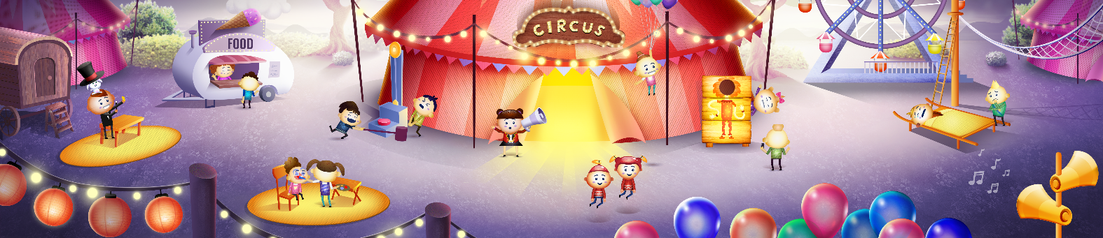

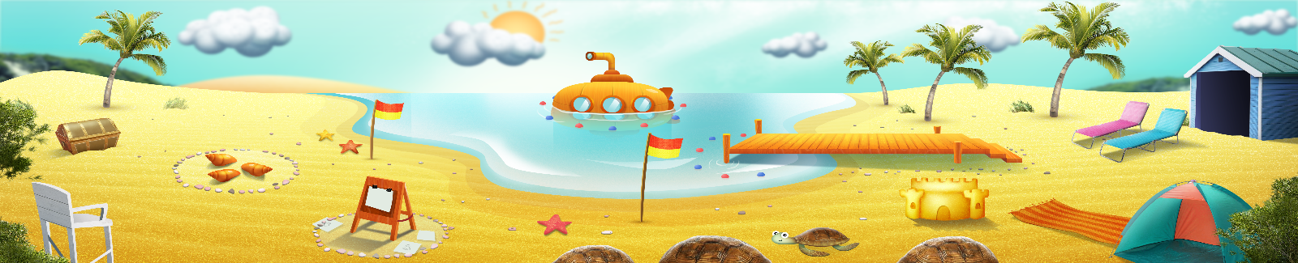




ELLA is funded by the Australian Government Department of Education, Skills and Employment and is managed by Education Services Australia. © 2021 Commonwealth of Australia, unless otherwise indicated. This material, other than Commonwealth trade marks in The Polyglots characters and The Polyglots logo, may be used in accordance with the Creative Commons BY-NC 4.0 licence unless otherwise indicated.

