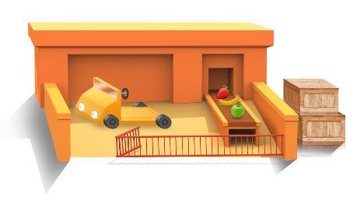
App 4: The Polyglots at the Zoo
Fruit sorter
Mathematics
In the ‘Fruit sorter’ learning experience, different pieces of fruit appear on the conveyor belt. Ask your students if they notice any patterns as the pieces appear. Students then create their own fruit patterns. Provide students with an A3 piece of paper and encourage them to illustrate several conveyor belts showing different fruit patterns. Encourage them to practise saying the names of the fruit using the target language.
Australian Curriculum links (Foundation): ACMNA005
Health and Physical Education
Play a game of fruit salad. Organise students in a circle in the middle of a basketball court or similar space and form them into four groups, each with the name of a fruit in the target language. Appoint a special place around the edges of that space to each. Tell students that when they next hear you call their fruit they are to move (run/skip/jump, as appropriate) to that place. When you call ‘Fruit salad!’, they must hurry back into the middle of the space and into the ‘fruit bowl’.
Australian Curriculum links (Foundation): ACPMP009 and ACPMP012
Assessment opportunities: The apps have been developed with subject matter experts. They are aligned to and support the learning outcomes of the Australian Curriculum: Languages for F–2.
You can find specific links to the Australian Curriculum for your language on the ELLA website, in the Educator Zone App Toolkit.

Learning intentions: We are learning to say the names of some fruit and describe their colours in ________ (language).
Success criteria: I can name some fruits and say their colours in ________ (language).
Resources: App 4, App 4 guide, ‘Fruit bingo game’ printable, A3 paper, coloured paper, ‘Fruit and colour sorting’ printable
Health and Physical Education
Follow the instructions on the ‘Fruit and colour sorting’ printable to create the toys and sorting crates. In small groups, students can then re-enact the ‘Fruit sorter’ learning experience and practise saying the names and colours of each fruit, using the target language.
Australian Curriculum links (Foundation): ACPPS004
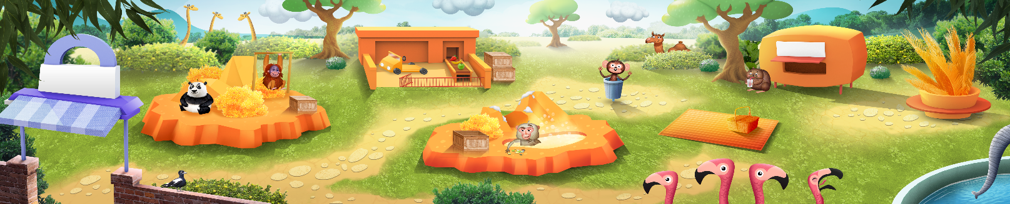
English
Print out the pages relevant to your target language from the ‘Fruit bingo game’ printable. Make enough duplicate copies for your students to play various games such as memory, bingo or snap. Encourage students to practise saying the names of the fruit using the target language as they play.
Australian Curriculum links (Foundation): ACELY1646

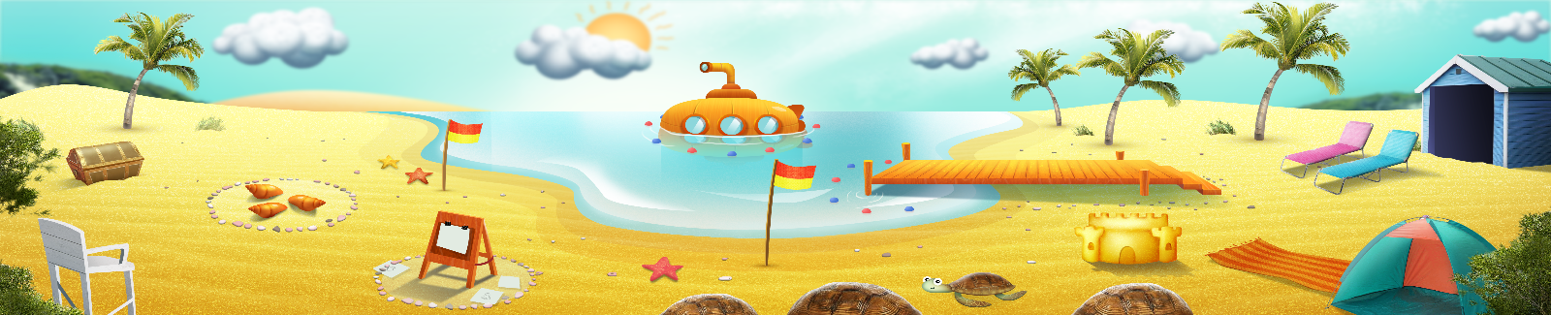


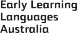

ELLA is funded by the Australian Government Department of Education, Skills and Employment and is managed by Education Services Australia. © 2021 Commonwealth of Australia, unless otherwise indicated. This material, other than Commonwealth trade marks in The Polyglots characters and The Polyglots logo, may be used in accordance with the Creative Commons BY-NC 4.0 licence unless otherwise indicated.

