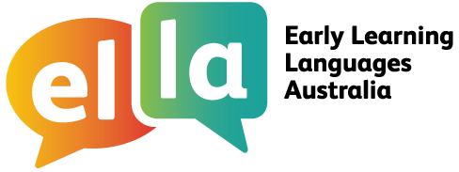

Things I can do in Arabic
Arabic
I have been learning Arabic using The Polyglots apps.

Here are some of the things I can do in the language:
Doing sometimes Beginning to do Regularly doing with assistance independently confidently

App 1: The Polyglots in the Playroom
I can sing a song in Arabic
I can say some simple greetings in Arabic I can introduce myself in Arabic

App 2: The Polyglots at the Beach

I can name some colours in Arabic
I understand some simple instructions in Arabic I can express some likes and dislikes in Arabic

App 3: The Polyglots at the Birthday Party

I can count to 10 in Arabic
I can say how old I am in Arabic
I can say happy birthday in Arabic

App 4: The Polyglots at the Zoo

I can name some fruits in Arabic
I can say I'm hungry/thirsty in Arabic I can say thank you in Arabic
I can make simple requests in Arabic

App 5: The Polyglots at the Circus

I can name some body parts in Arabic
I can say some parts of the face in Arabic I can say something hurts in Arabic
I can use some adjectives in Arabic (eg big/small)

App 6: The Polyglots at the Park
I can respond to some simple instructions in Arabic using action words
I can give some simple instructions in Arabic using action words
I can use some adverbs in Arabic (eg quickly/slowly)
App 7: The Polyglots in the Town
I can name some shapes in Arabic
I can recognise the meaning of some words written in Arabic I can say goodbye in Arabic
ELLA is funded by the Australian Government Department of Education and is managed by Education Services Australia. © 2019 Commonwealth of Australia, unless otherwise indicated. This material, other than Commonwealth trade marks in The Polyglots characters and The Polyglots logo, may be used in accordance with the Creative Commons BY-NC 4.0 licence, unless otherwise indicated.
Education Services Australia Limited ABN 18 007 342 421
Level 5 440 Collins Street, Melbourne Victoria 3000 Australia
www.esa.edu.au E ella@esa.edu.au
T +61 3 9207 9600 ELLA helpdesk 1800 468 303





