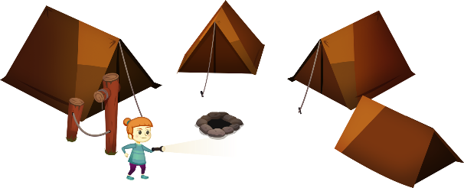
App 9: The Polyglots Go Camping
Spotlight
Learning intentions: We are learning how to say the names of family members in ___________________ (language).
Success criteria: I can say the name of some family members using _____________ (language).
Resources: App 9, App 9 guide, camping equipment, A3 paper, art materials
English; Visual Arts
Students illustrate a camping scene, perhaps using black paper and grey lead pencils to represent the night scene. They can also show a ‘lit up’ area to represent the torchlight. Missing family members can be hiding under flaps of paper. When these are lifted up, they are revealed! Students practise writing ‘You found me!’, using the target language. Refer to the App 9 guide for more details.
Australian Curriculum links (Year 1): ACELY1661 and ACAVAM108
Health and Physical Education
Students play a game of hide and seek in the playground. Students take it in turns to play the part of the missing family members, and hide from the student playing Min or Kai. Encourage students to use the target language and practise phrases such as ‘I’m coming!’ and ‘You found me!’ when searching for the missing family members.
Australian Curriculum links (Year 1): ACPMP027

Science; Humanities and Social Sciences
In the Spotlight learning experience, possums – rather than family members – sometimes appear from the bush. Generate a class discussion about Australian bush animals and the environments (habitats) in which they live, discussing both nocturnal and diurnal animals. How can we help to look after these habitats and, in turn, help to care for these native animals?
Australian Curriculum links (Year 1): ACSSU211 and ACHASSK031

Assessment opportunities: The apps have been developed with subject matter experts. They are aligned
to and support the learning outcomes of the Australian Curriculum: Languages for F–2.
Specific links to the Australian Curriculum for your language can be found on the ELLA website, in the
Educator Zone App Toolkit.
Drama
Provide your students with various items of safe camping equipment (a tent, torch, possum puppet, etc) and create a dramatic play area in your learning space. Students imitate the Spotlight learning experience and take it in turns to role-play the different characters. They practise phrases from the app such as ‘Is that Grandma?’ and ‘You found me!’, using the target language.
Australian Curriculum links (Year 1): ACADRM027

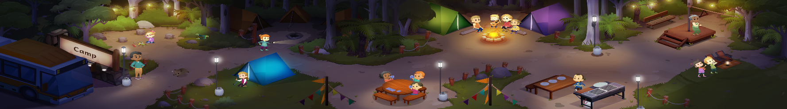




ELLA is funded by the Australian Government Department of Education, Skills and Employment and is managed by Education Services Australia. © 2020 Commonwealth of Australia, unless otherwise indicated. This material, other than Commonwealth trade marks in The Polyglots characters and The Polyglots logo, may be used in accordance with the Creative Commons BY-NC 4.0 licence unless otherwise indicated.

