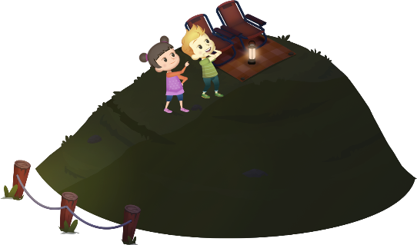
App 9: The Polyglots Go Camping
Stargazing
Learning intentions: We are learning how to count to 20 in ___________________ (language) and how to skip count by twos, fives and tens in ___________________ (language).
Success criteria: I can count to 20 in ___________________ (language) and skip count by twos, fives and tens in _____________ (language).
Resources: App 9, App 9 guide, A3 paper, counters.
English; Mathematics; Visual Arts
Students can create a colourful ‘number’ poster about one of the newly learnt numbers in the target language. They could represent the number in various ways, eg write the number in English and in the target language and as a digit, draw it as a collection and as an array and show it on a drawn or painted hand. The number posters could then be displayed in a sequential order around the classroom.
Australian Curriculum links (Year 1): ACELY1661, ACMNA013 and ACAVAM108
English; Visual Arts
The Stargazing learning activity contains many images named in the target language. As a whole class, create a list of the different images that are within this activity. Students then choose which image they would like to both draw and then label using the target language. Refer to the App 9 guide for details of the language.
Australian Curriculum links (Year 1): ACELY1661 and ACAVAM108

Science
Generate a whole-class discussion about the sky, comparing how it looks during the day and at night. Talk about the appearance of the sun and clouds and the moon and stars. Students demonstrate their knowledge by illustrating the difference between day sky and night sky, or by representing the similarities and differences as a Venn diagram.
Australian Curriculum links (Year 1): ACSSU019

Assessment opportunities: The apps have been developed with subject matter experts. They are aligned
to and support the learning outcomes of the Australian Curriculum: Languages for F–2.
Specific links to the Australian Curriculum for your language can be found on the ELLA website, in the
Educator Zone App Toolkit.
English; Mathematics
As a whole class, play a game of Buzz, counting from 1 to 20 or skip counting by twos, fives and tens using the target language. All students stand in a circle and decide which number will be replaced with the word ‘Buzz’. Then, counting around the circle, each student is to say the subsequent number (or the next skip-counting number) except for the agreed ‘Buzz’ number.
Australian Curriculum links (Year 1): ACELY1788
and ACMNA012

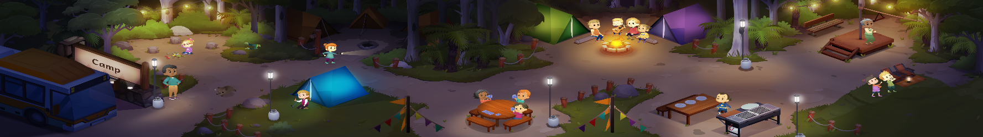




ELLA is funded by the Australian Government Department of Education, Skills and Employment and is managed by Education Services Australia. © 2020 Commonwealth of Australia, unless otherwise indicated. This material, other than Commonwealth trade marks in The Polyglots characters and The Polyglots logo, may be used in accordance with the Creative Commons BY-NC 4.0 licence unless otherwise indicated.

