
App 3: The Polyglots at the Birthday Party
Balloons
English; Mathematics
Incorporate the target language during whole-class counting activities, using the number chart printable. When students are more familiar with the language, play a game of Buzz based on the numbers 1 to 10. With students in a circle, agree on the number that the word ‘buzz’ will replace.
In turn, students call the correct number from 1 to 10, using the target language. The student who gets the agreed number should call out ‘Buzz!’ to stay in, then the game re-starts.
Australian Curriculum links (Foundation): ACELY1646 and ACMNA001
Assessment opportunities: The apps have been developed with subject matter experts. They are aligned to and support the learning outcomes of the Australian Curriculum: Languages for F–2.
You can find specific links to the Australian Curriculum for your language on the ELLA website, in the Educator Zone App Toolkit.
Mathematics
Students practise writing the numbers from one to ten in the target language, using digits or words. Encourage them to make connections between writing in English and writing in the target language. Provide different writing tools such as icy-pole sticks, matchsticks, pipe cleaners, plasticine, sand trays.
Australian Curriculum links (Foundation): ACMNA002
Learning intentions: We are learning how to count to ten in ________ (language).
Success criteria: I can count to ten and can recognise the numbers from 1 to 10 in _______ (language).
Resources: App 3, App 3 guide, number chart printable, A3 paper, coloured paper, various ‘writing’ tools (icy-pole sticks, matchsticks, plasticine, sand trays), various craft materials (such as crayons, paint).

Visual Arts
Selecting from a range of craft materials such as coloured paper, crayons and paint, students design and create their own coloured balloon scene. They first choose a number, then illustrate a Polyglots character holding that number of coloured balloons.
Australian Curriculum links (Foundation): ACAVAM108

Mathematics
Encourage students to use the target language when they count, add and subitise objects during maths activities. Have students create colourful number facts posters to show what they know about a chosen number from 1 to 10. They write and draw facts about that number – for example, the number in English and in the target language, as a digit, as a collection, as an array, as shown on one or two hands.
Australian Curriculum links (Foundation): ACMNA002

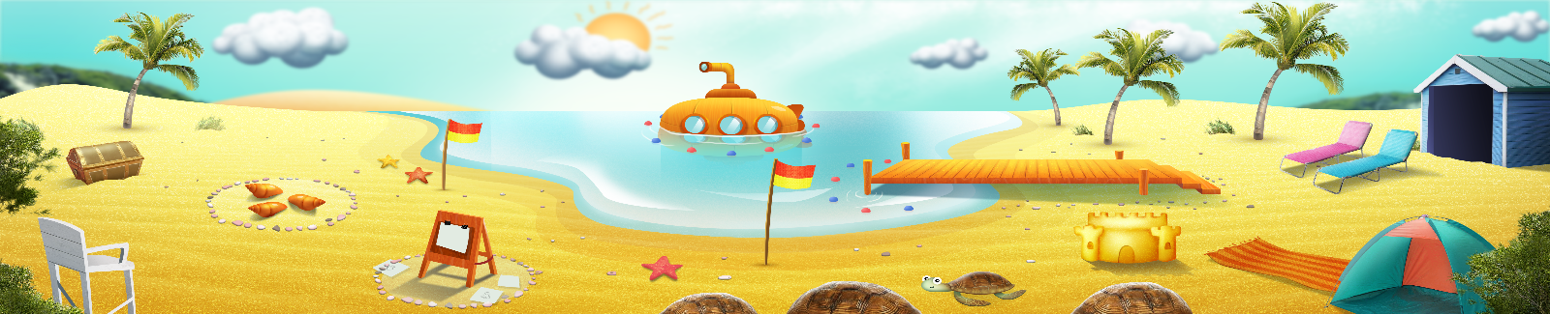


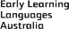

ELLA is funded by the Australian Government Department of Education, Skills and Employment and is managed by Education Services Australia. © 2021 Commonwealth of Australia, unless otherwise indicated. This material, other than Commonwealth trade marks in The Polyglots characters and The Polyglots logo, may be used in accordance with the Creative Commons BY-NC 4.0 licence unless otherwise indicated.

