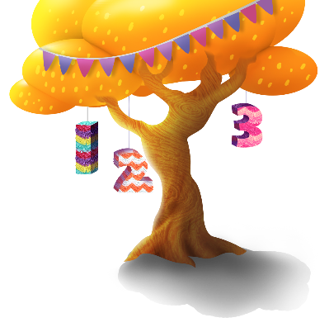
App 3: The Polyglots at the Birthday Party
Song tree
Visual Arts
Students design and create their own birthday-party scene, taking inspiration from the App 3 playspace. They select from a range of craft materials such as crayons, paint and fabric pieces. They may also like to use the characters from the character artwork printable.
Australian Curriculum links (Foundation): ACAVAM108
Assessment opportunities: The apps have been developed with subject matter experts. They are aligned to and support the learning outcomes of the Australian Curriculum: Languages for F–2.
You can find specific links to the Australian Curriculum for your language on the ELLA website, in the Educator Zone App Toolkit.

Music
Provide students with a range of small percussion instruments (such as cymbals, tambourines, triangles, maracas) to create a ‘number composition’ that they will perform in pairs. Their performance must include a chosen number of beats which, when played, the audience members must count using the target language.
Australian Curriculum links (Foundation): ACAMUM082
English
Start a discussion about the history of piñatas at birthday celebrations. What other items are seen at birthday celebrations? Discuss the common things such as decorations, games, food, music and saying ‘Happy birthday’, then the cultural aspects of traditional birthday celebrations in a country where the language is spoken. Compare similarities and differences with other birthday parties (include birthday greetings). Students illustrate their learnings and create a class birthday calendar together. Use the birthday poster printable to celebrate student birthdays.
Australian Curriculum links (Foundation): ACELY1784 and ACHASSK012
Dance; Music
As a whole class, explore different types of traditional performances in the countries where the target language is spoken. Encourage students to observe the features of these performances: costumes, movements, instruments. Talk about the similarities between performances. What do the students notice about them? Students could illustrate their favourite performance on A3 poster paper.
Australian Curriculum links (Foundation): ACADAR004 and ACAMUR083
Learning intentions: We are learning about the different types of musical performances in the countries where ________ (language) is spoken.
Success criteria: I can talk about the features of musical performances in the countries where ________ (language) is spoken.
Resources: App 3, App 3 guide, A3 paper, ‘Happy birthday poster’ printable, a selection of small percussion instruments, character artwork printable, craft materials such as crayons, paint, fabric pieces.
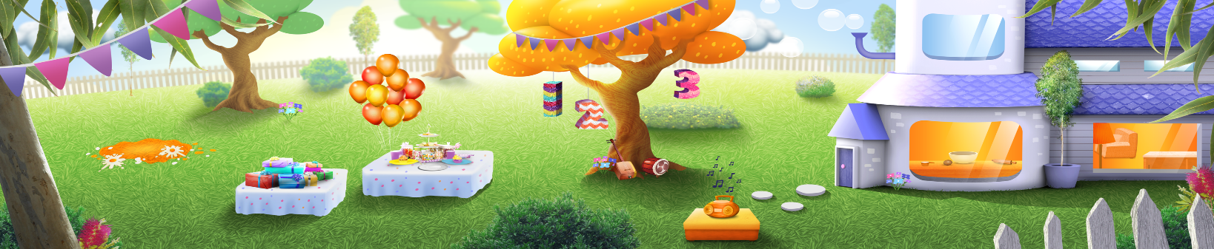

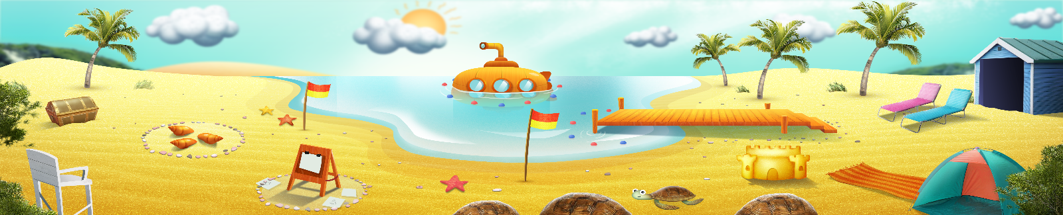


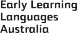

ELLA is funded by the Australian Government Department of Education, Skills and Employment and is managed by Education Services Australia. © 2021 Commonwealth of Australia, unless otherwise indicated. This material, other than Commonwealth trade marks in The Polyglots characters and The Polyglots logo, may be used in accordance with the Creative Commons BY-NC 4.0 licence unless otherwise indicated.

