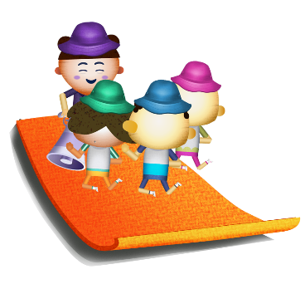
App 6: The Polyglots at the Park
Warm-up trainer
English; Physical Education
Students create their own game of ‘Warm-up trainer’ using the ‘Action dice and poster’ printable. Print copies of the dice, the corresponding page of action words and the stop sign. Fold and prepare the dice. Model a whole-class game. Then have students play the game in small groups, taking it in turns to be the leader who gives instructions for their teammates, using the target language.
Australian Curriculum links (Foundation): ACELY1646 and ACPMP009
Health and Physical Education
Generate a class discussion about the importance of physical activity. Why is being active good for our bodies? Investigate the need to warm up our muscles before we commence a sporting activity. Talk about stretches and how different parts of the body respond to exercise. You may like to practise some stretches and short physical activities with your students, as appropriate to your class.
Australian Curriculum links (Foundation): ACPMP010
Assessment opportunities: The apps have been developed with subject matter experts. They are aligned to and support the learning outcomes of the Australian Curriculum: Languages for F–2.
You can find specific links to the Australian Curriculum for your language on the ELLA website, in the Educator Zone App Toolkit.
Health and Physical Education
‘Warm-up trainer’ looks at verbs such as jump, dance and run. The ‘Action dice and poster’ printable also includes the verb stop (in the stop sign). Explore different types of road signs in the country/countries where the target language is spoken. What is the same as here? What is different? Why would some signs or symbols be the same in different countries? You could use ‘No entry’ as a good example to start with.
Australian Curriculum links (Foundation): ACPPS006
English
Students encounter many verbs and are introduced to some adverbs throughout this learning experience. As a whole class, begin to explore how verbs are used in sentences and how the inclusion of adverbs can enhance meaning. Students practise writing some sentences (in English) such as; ‘I can ran fast’ or ‘I can jump slowly’. By adding an illustration, students will demonstrate their knowledge.
Australian Curriculum links (Foundation): ACELY1651 and ACELA1437
Learning intentions: We are learning how to use verbs and some adverbs to give instructions using ________ (language).
Success criteria: I can provide instructions using verbs and some adverbs in ________ (language).
Resources: App 6, App 6 guide, ‘Action dice and poster’ printable (and enough pre-prepared action dice for small group play)
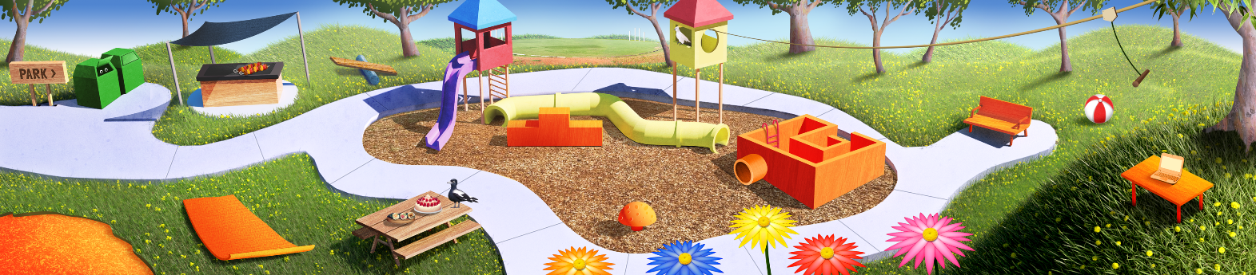




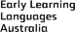

ELLA is funded by the Australian Government Department of Education, Skills and Employment and is managed by Education Services Australia. © 2021 Commonwealth of Australia, unless otherwise indicated. This material, other than Commonwealth trade marks in The Polyglots characters and The Polyglots logo, may be used in accordance with the Creative Commons BY-NC 4.0 licence unless otherwise indicated.

